Assignment05
Sequence Diagram
Football Club Management

Group-20
Kazi Ehsanul Mubin
ID-18101391
Umma Tania Arafin
ID- 18201203
CSE471 Lab Project
Section 02

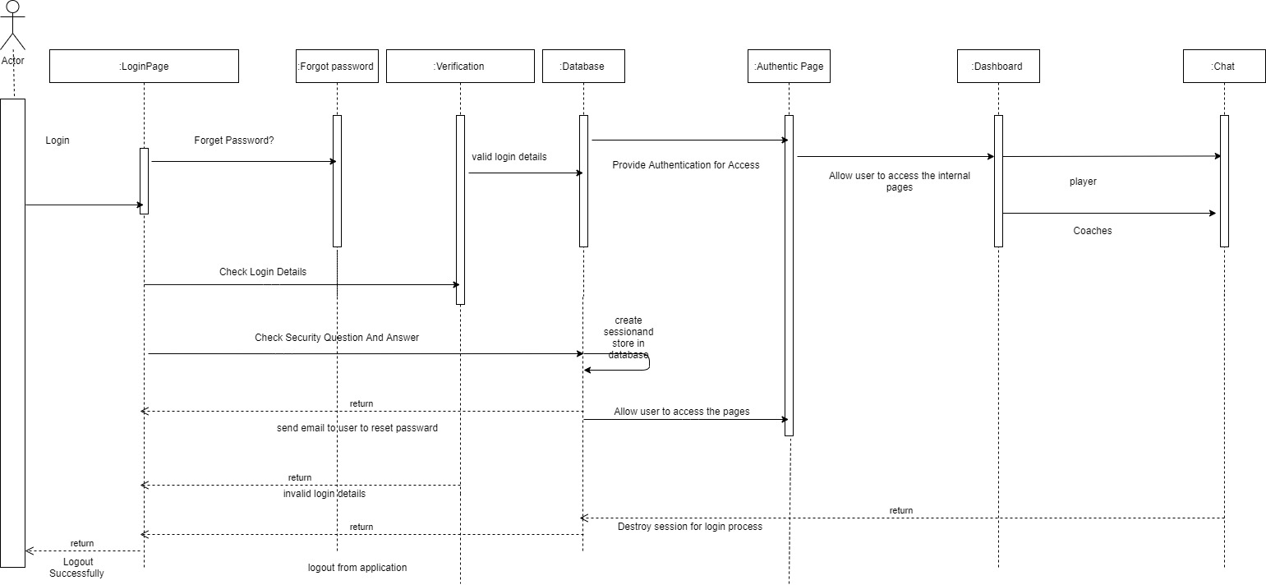
Sequence Diagram-

